# Introduction:

This project was undertaken with the goal of building a Meeting Intelligence Application. The application allows users to upload mp3 recordings of the meeting. The Application then processes the audio file to generate the transcript of the meeting and store it in the s3 bucket. The user would be able to select the recording from a list of processed meetings, which generates the Generic Questionnaire. The user will also be able to ask questions about the selected meeting.

Technologies used in the project.

* Streamlit
* Airflow
* Docker
* Google Cloud Platform
* AWS S3

# Streamlit

# Streamlit is a Python library that includes built-in tools for data visualization and user input/output and is designed to be easy to use and require minimal setup. Streamlit can be used for data exploration, machine learning, and prototyping/testing, making it accessible to a wide range of users and use cases. Overall, Streamlit is a powerful and versatile library for building interactive web applications without the need for extensive web development experience.

Below is the web app which we designed using Streamlit package:

* Upload Page

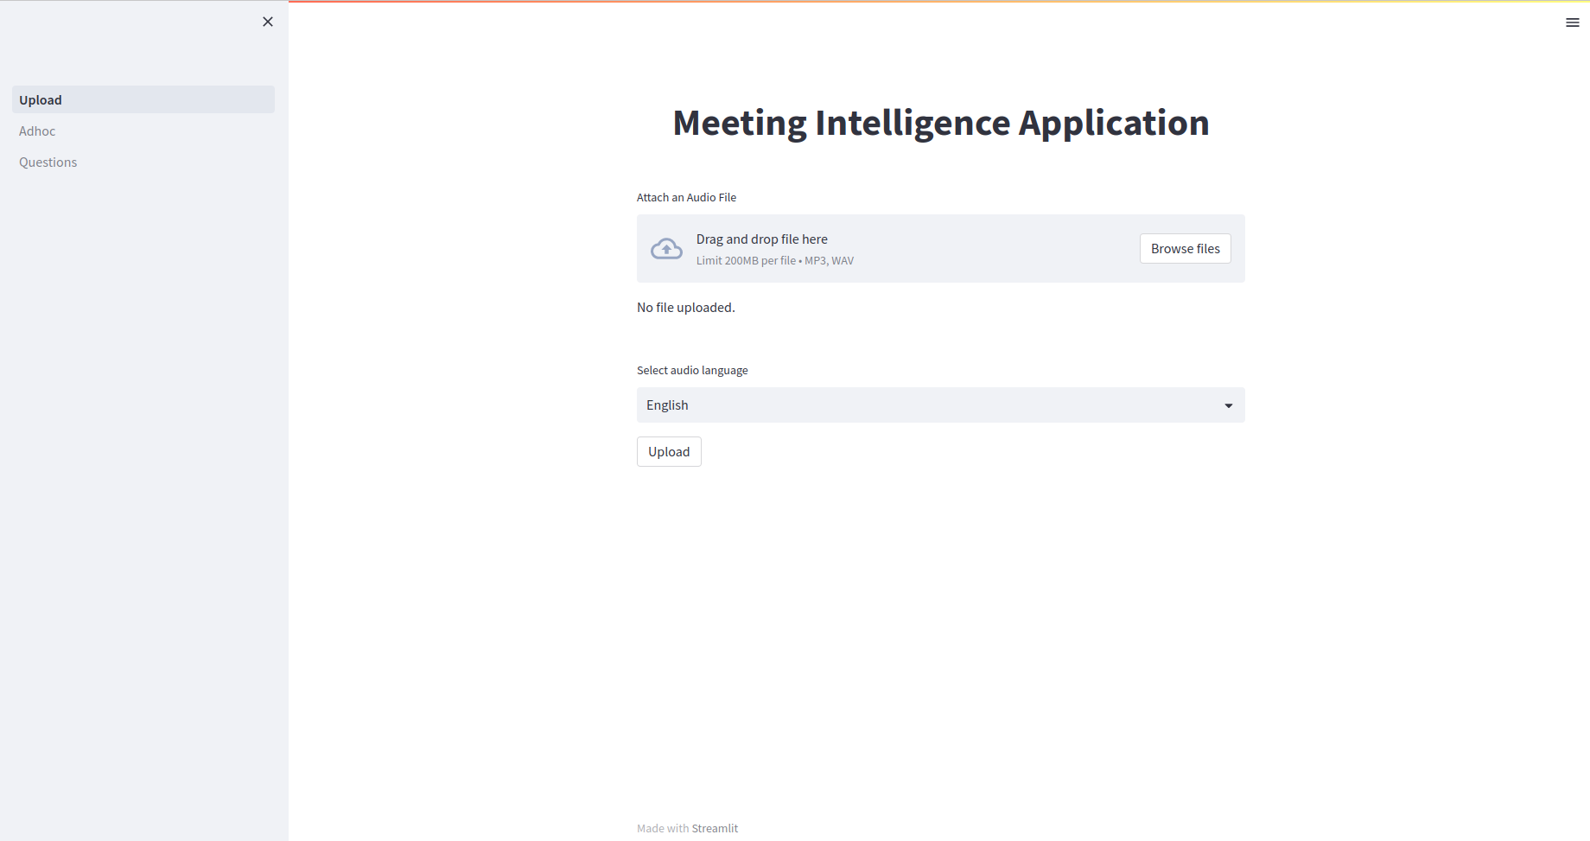

Here you can upload the audio file; once it is called, the audio file will be uploaded to the s3 bucket, and the corresponding transcript would be generated in the s3 bucket under the processed folder.

* Adhoc Page

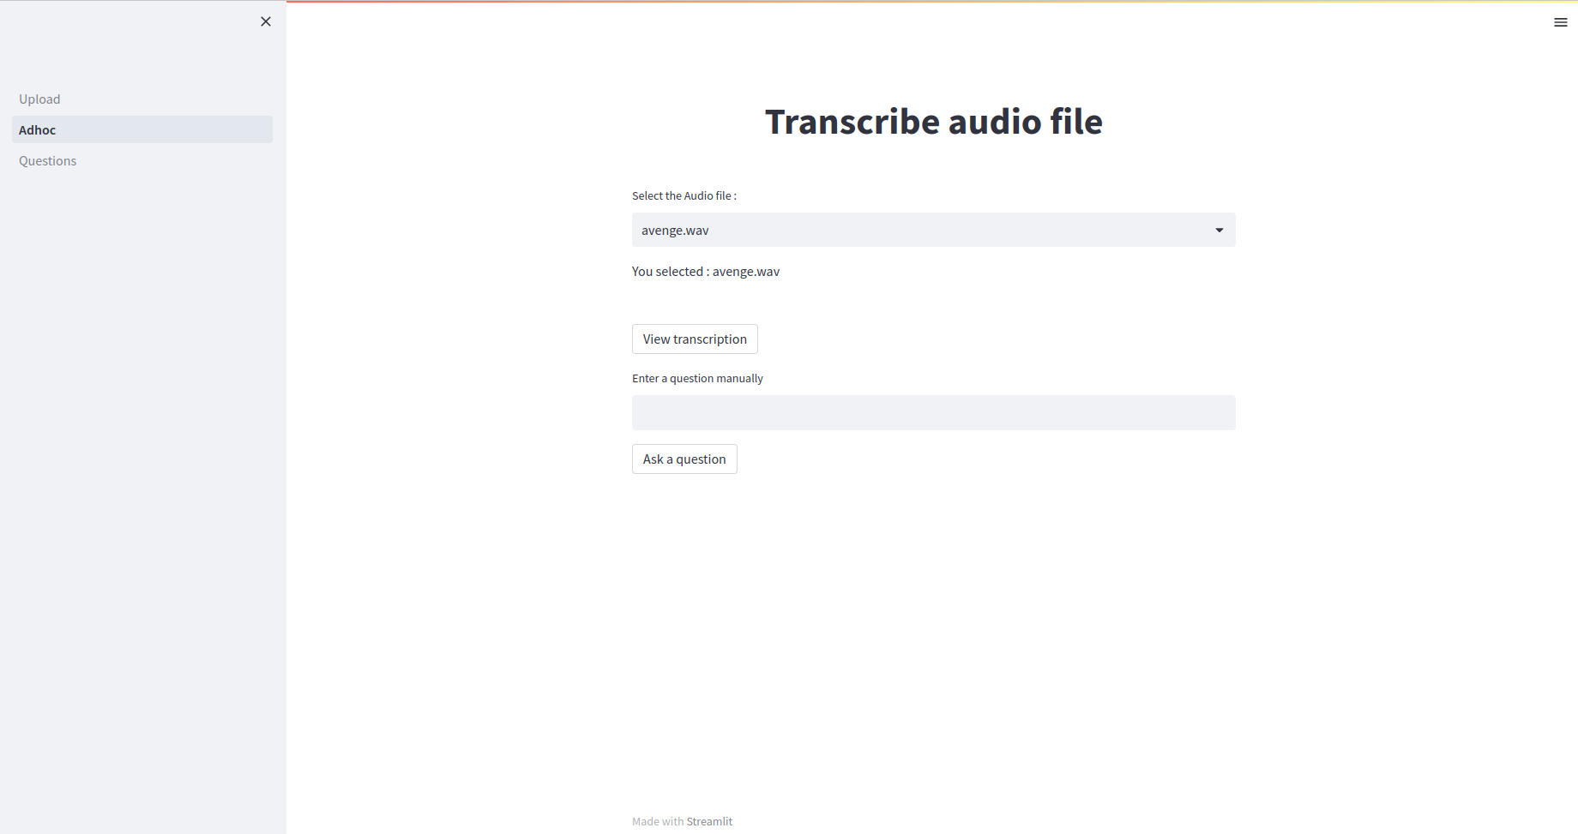

Here you can select the name of the audio file from the list of processed audio files, and you would be able to get the transcript of the audio file and the generic questionnaire as well.

# Airflow:

### Adhoc_dag.py

This Python script defines an Airflow DAG named " Adhoc_dag.py ". The purpose of this DAG is to read the audio file from S3, send the audio file to whisper API, write the transcript of the audio file into S3’s processed folder, call the chat gpt API to generate generic questionnaire.

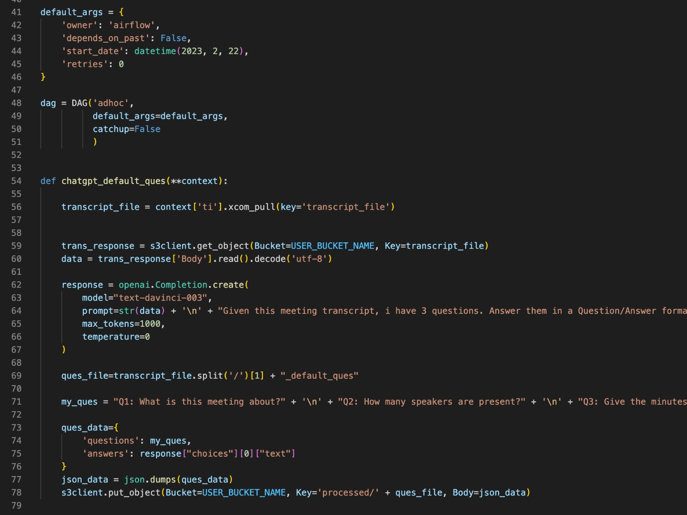

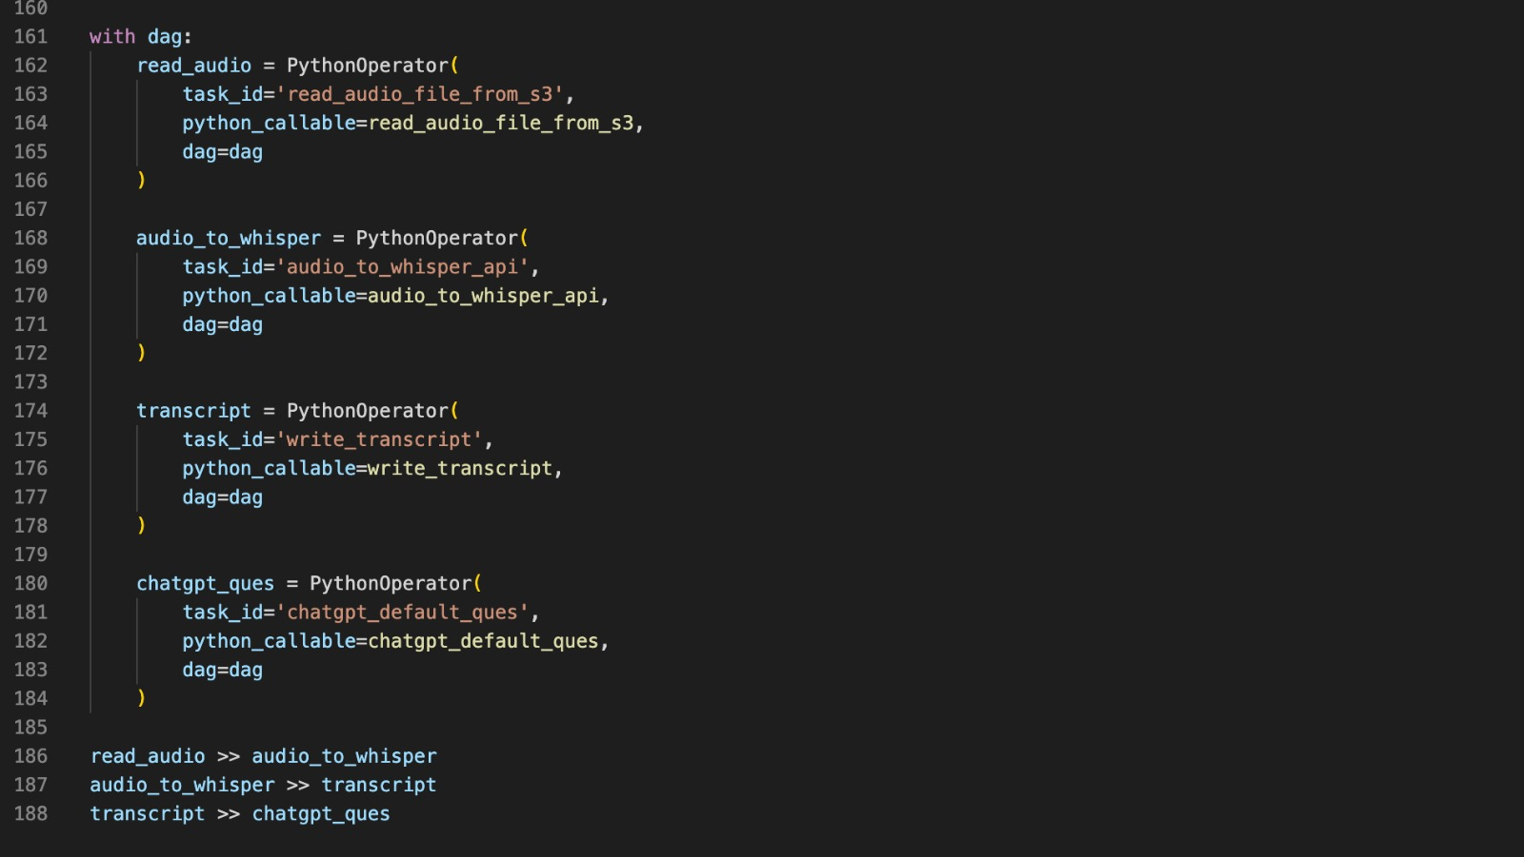

### Batch_dag.py

This Python script defines an Airflow DAG named "Batch_dag.py". The purpose of this DAG is to Read all the files from s3 bucket, send the audio files to whisper api, write the Transcripts into S3s processed folder.

